**COLLABORATIVE PROJECT WITH INTEL**

**PROJECT TITLE : ACCIDENT LOCATIONS IN INDIAN ROADS**

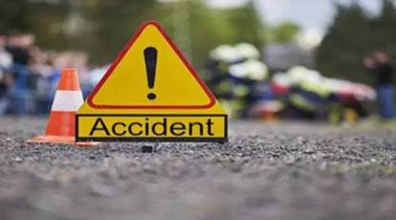 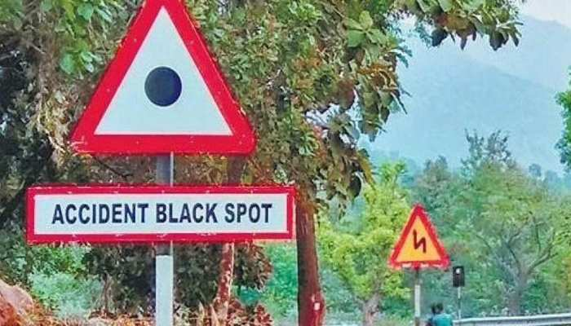

**TEAM NAME :** **TRACKERS**

**Team Mentor : Dr T V RAJINI KANTH, Professor & Head,**

**Department of CSE-AI&ML**

[**rajinitv@gmail.com**](mailto:rajinitv@gmail.com)**,** [**rajinikanthtv@sreenidhi.edu.in**](mailto:rajinikanthtv@sreenidhi.edu.in)

**Ph. No: 9849414375**

# Team Members : VSJ VAISHNAVI Roll no: 21311A6646 CSE Team lead

D HITHASHREERoll no: 22315A6601 CSE Team member

**Institute Name : SreeNidhi Institute of Science and Technology**

**Yamnam Pet, Ghatkesar**

**Hyderabad - 501301**

**Date of submission : 15 -07- 2023**

**ABSTRACT:**

There are many inventories in automobile industries to design and build safety measures for automobiles, but traffic accidents are unavoidable. There is a huge number of accidents prevailing in all urban and rural areas. Patterns are involved with different circumstances can be detected by developing an accurate prediction models which will be capable of automatic separation of various accidental scenarios.

These cluster will be useful to prevent accidents and develop safety measures. We believe to acquire maximum possibilities of accident reduction using low budget resources by using some scientific measures.

Today road traffic injuries are one of the leading causes of deaths, disabilities and hospitalizations with severe socioeconomic costs across the world. India’s road network, besides being the lifeline of the Nation and a major contributor to socioeconomic growth and development, also has the largest contribution to accidental deaths in the country with road accidents In India, flawed road designing and engineering, weak enforcement of traffic laws and lack of rapid trauma care contribute to the high number of road accidents and deaths.

# INTRODUCTION

India is home to the second largest road network in the world with a total road length of approximately 62.1 lakh kilometres. This massive network serves as the nation’s lifeline transporting over 64.5% of all goods within the country in addition to being the preferred option for move of over 90% of India’s passenger traffic.

There is a huge impact on the society due to traffic accidents where there is a great costs of fatalities and injuries. In recent years, there is a increase in the researches attention to determine the significantly affect the severity of the drivers injuries which is caused due to the road accidents.

Accurate and comprehensive accident records are the basis of accident analysis. the effective use of accident records depends on some factors, like the accuracy of the data, record retention, and data analysis. There are many approaches applied to this scenario to study this problem.

An asymmetry exists between number of vehicles and deaths due to road accidents with India’s one percent global share of number of vehicles accounting for almost 11% deaths due to road accidents. Road accidents continue to remain the leading cause of deaths, disabilities and hospitalisations in the country despite concerted efforts at all levels to contain these.

# MOTIVATION

Models are created using accident data records which can help to understand the characteristics of many features like drivers behavior, roadway conditions, light condition, weather conditions and so on. This can help the users to compute the safety measures which is useful to avoid accidents.

It can be illustrated how statistical method based on directed graphs, by comparing two scenarios based on out-of-sample forecasts. the model is performed to identify statistically significant factors which can be able to predict the probabilities of crashes and injury that can be used to perform a risk factor and reduce it.

The Intel Industrial Training initiative Unnati Program helps the students in getting the flavour of Industrial View of the work planning, interaction and guidance of Intel Team and friendly competing with other college students.

# DATA SOURCES:

**MORTH WEBSITE**:

<https://morth.nic.in/black-spot>,

Research Datasets: Academic research papers and studies on accident locations and blackspots have provided valuable datasets for our project.

Developed code to take the input as libraries and code and generates output map with various accident locations.

Developed a program to analyse various accident locations in Andhra Pradesh.

# PYTHON LIBRARIES USED IN THE PROGRAMS

1.**PANDAS:** It is a Python library used for working with data sets. It has functions for analyzing, cleaning, exploring, and manipulating data. The name "Pandas" has a reference to both "Panel Data", and "Python Data Analysis"

2.**MATPLOTLIB:** It is a comprehensive library for creating static, animated, and interactive visualizations in Python.

3.**NUMPY:** NumPy is a library for the Python programming language, adding support for large, multi-dimensional arrays and matrices, along with a large collection of high-level mathematical functions to operate on these arrays.

4.**BASEMAP:** basemap is a great tool for creating maps using python in a simple way. It’s a [matplotlib](http://matplotlib.org/) extension, so it has got all its features to create data visualizations, and adds the geographical projections and some datasets to be able to plot coast  lines, countries, and so on directly from the library.

5.**GEOPY:** geopy allows you to connect to a large number of geocoding webs. Geopy makes it easy for python developers to locate the coordinates of addresses, cities, countries, and landmarks across the globe.

# LITERATURE SURVEY:

Sachin Kumar used data mining techniques to identify the locations where high frequency accidents are occurred and then analayze them to identify the factors that have an effect on road accidents at that locations. The first task is to divide the accident location into k groups using the k-means clustering algorithm based on road accident frequency counts. Then, association rule mining algorithm applied in order to find out the relationship between distinct attributes which are in accident data set and according to that know the characteristics of locations.

# ARCHITECTURE

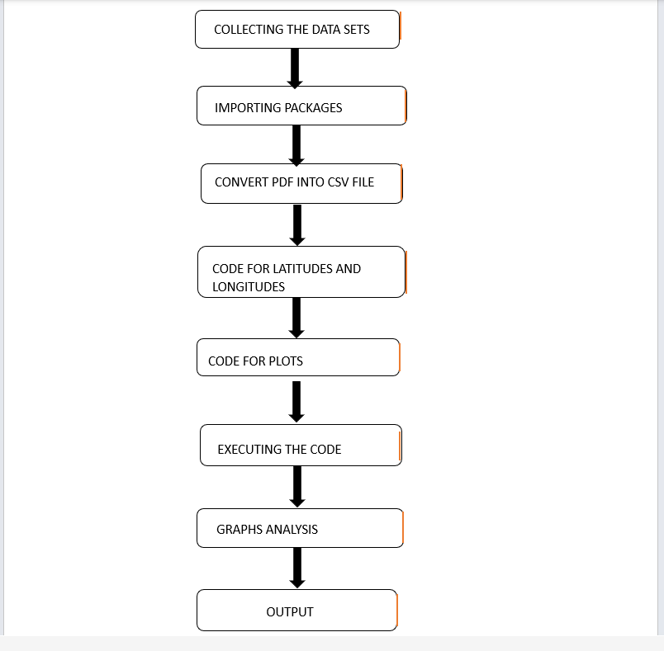

Fig 1. Architecture

# RESULTS

## Fig 2. Map of Black spots and no. of deaths beside

## Some identified images which motivate this study (Images may disturb)

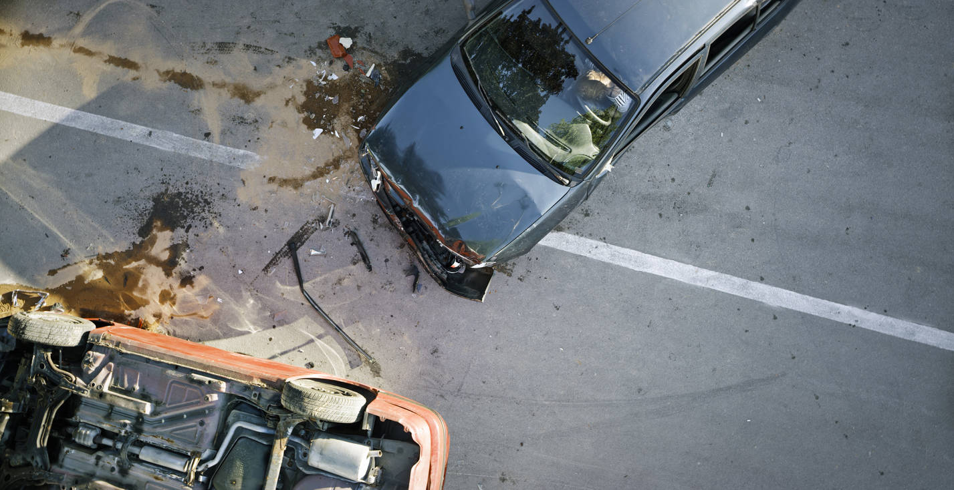

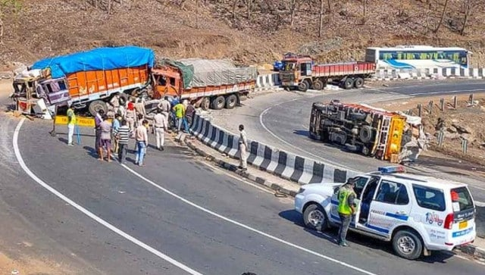

LAWS FOR ACCIDENTS AND ROAD SAFETY**:**

1. Section 80 of IPC talks about accident as a general defence.

SECTION 80: Accident in doing a lawful act. Nothing is an offence which is done by accident or misfortune, and without any criminal intention or knowledge in the doing of a lawful act in a lawful manner by lawful means and with proper care and caution.

1. Section 279 of the Indian Penal Code (IPC) deals with the offence of rash driving or riding on a public way. According to this section, the minimum punishment for committing such an offence is a fine that is less than one thousand rupees, or imprisonment that is less than six months.

**FOR MORE INFORMATION:** <https://getlegalindia.com/car-crash/>

# CONCLUSION

In conclusion, our project focused on ANALYSING ACCIDENT LOCATIONS ON INDIAN ROADS using machine learning. We utilized a dataset consisting of news articles with features such as Title, Text, Subject, and Date.

Here the road accident study is done by analyzing some data by giving some queries which is relevant to the study. The queries like what is the most dangerous time to drive , what fractions of accidents occur in rural, urban and other areas. What is the trend in the number of accidents that occur each year, do accidents in high speed limit areas have more casualties and so on

These data can be accessed using Microsoft excel sheet and the required answer can be obtained. This analysis aims to highlight the data of the most importance in a road traffic accident and allow predictions to be made. The results from this methodology can be seen in the next section of the report.

# REFERENCES

1. <https://www.pantechsolutions.net/road-accident-analysis-using-machine-learning>
2. <https://getlegalindia.com/car-crash/>
3. <https://www.researchgate.net/publication/348222653_Machine_Learning_Approach_Towards_Road_Accident_Analysis_in_India>
4. <https://dst.gov.in/ai-make-roads-india-safer-drive>
5. <https://morth.nic.in/black-spot>
6. <https://www.newindianexpress.com/states/andhra-pradesh/2022/feb/15/520-black-spots-on-roads-across-andhra-pradesh-rectified-2419619.html>

# SOURCE CODE AND Datasets

acc_loc_Team1.ipynb

black_spots_data.csv